Name:P.Gayathri
Reg.No:192424324

11:

Aim:

To write a Python program to implement the A* (A-Star) Algorithm to find the shortest path between a start node and a goal node.
Algorithm:
Step 1: Start the program.
Step 2: Create a graph with nodes and edge costs.
Step 3: Define the heuristic values for each node.
Step 4: Select the start node and goal node.
Step 5: Add the start node to the open list.
Step 6: Choose the node with the lowest f(n) = g(n) + h(n).
Step 7: Expand its neighbouring nodes.
Step 8: Update the path cost if a shorter path is found.
Step 9: Repeat until the goal node is reached.
Step 10: Display the shortest path.
Step 11: Stop the program.

PROGRAM:
graph = {
'A': [('B', 1), ('C', 3)],
'B': [('D', 3), ('E', 6)],
'C': [('F', 5)],

'D': [('G', 2)],
'E': [('G', 1)],
'F': [('G', 2)],
'G': []
}
heuristic = {
'A': 6,
'B': 5,
'C': 4,
'D': 2,
'E': 1,
'F': 2,
'G': 0
}
start = input("Enter Start Node: ")
goal = input("Enter Goal Node: ")
open_list = [(start, 0)]
visited = []
parent = {start: None}
cost = {start: 0}
print("\nSteps of A* Search:\n")
while open_list:
open_list.sort(key=lambda x: x[1] + heuristic[x[0]])
current = open_list.pop(0)[0]
print("Current Node:", current)
if current == goal:
break

visited.append(current)
for neighbor, weight in graph[current]:
new_cost = cost[current] + weight
if neighbor not in cost or new_cost < cost[neighbor]:
cost[neighbor] = new_cost
parent[neighbor] = current
open_list.append((neighbor, new_cost))
path = []
node = goal
while node is not None:
path.append(node)
node = parent[node]
path.reverse()
print("\nShortest Path:", " -> ".join(path))
print("Total Cost:", cost[goal])

INPUT:
Enter Start Node: A
Enter Goal Node: G
OUTPUT:
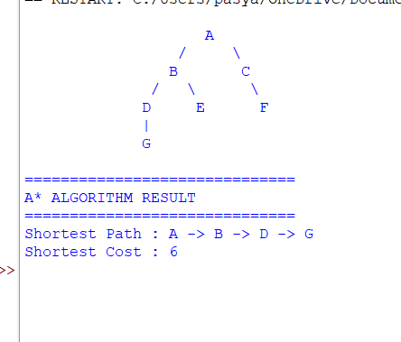

RESULT:
Thus, the Python program to implement the A* Algorithm was executed successfully, and the shortest path from the start node to the goal node was obtained.

